**10527124 資訊三甲 邱正皓**

1. Display the employee last name and department name for all employees who have an ‘S’ in their last name.

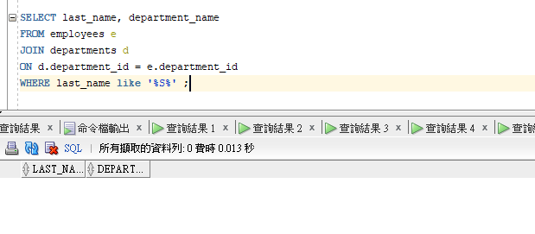

(b) Display the average, highest, lowest and sum of the monthly salaries and the

number of employees for each department and display the department name.

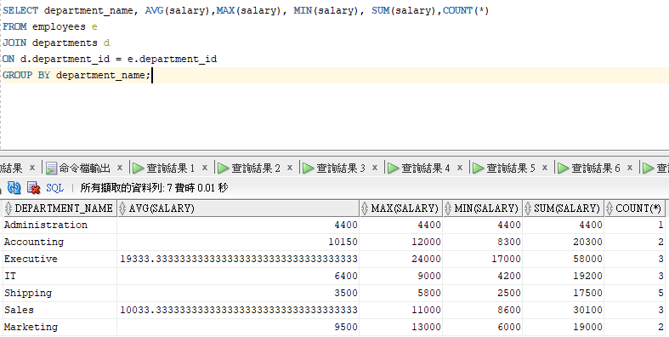

(c)Find the names of employees and their respective managers.

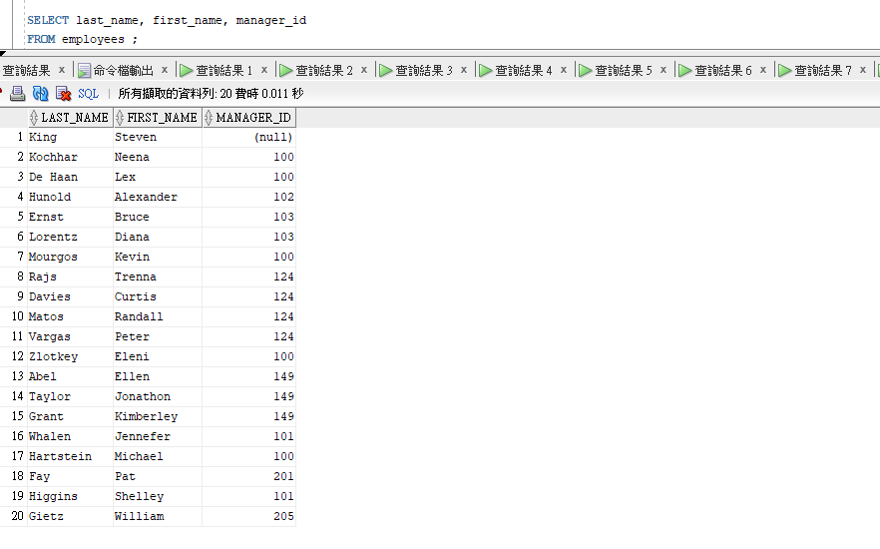

(d) Retrieve the name and their department name of employees who have minimum

salary.

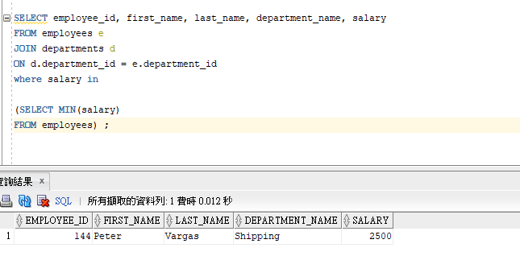

(e) Retrieve the name of employees who have minimum salary in their department.

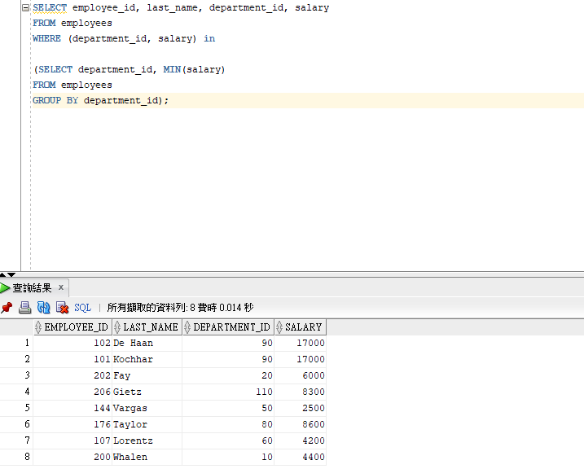

(f) Increase 10 % salary of all employees who belong to 'IT' department.

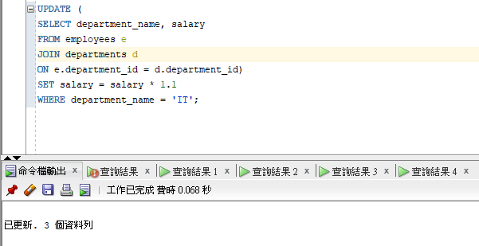

(g) Insert < 70, 'Public Relations', 100, 1700> into departments.

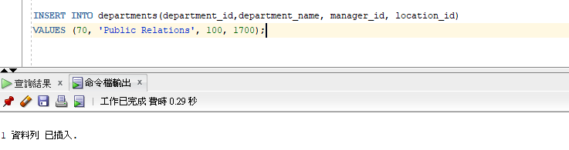

(h) Delete the EMPLOYEE tuple with employee_id is 206.

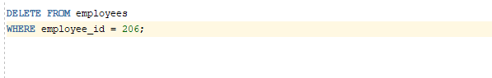



1. Modify the SALARY attribute of the employees 104 tuple with employee_id is 103.

